University Of Engineering and Technology, Lahore
Computer Engineering Department

Course Name: | Course Code: CMPE-112L
Assignment Type: | Dated: 16 FEB 2026
Semester: | Session:
Lab/Project/Assignment #: 1 | CLOs to be covered: CLO1
Lab Title: | Teacher Name: Hafiz Muhammad Mubashar
Lab Evaluation:

CLO1 | Apply appropriate programming techniques to create executable programs to solve well defined problems
 | Level1 | Level2 | Level3 | Level4 | Level5 | Level6
(5)
Total |  |  |  |  |  | /5
Rubrics for Current Lab Evaluation
Scale | Marks | Level | Rubric
Excellent | 5 | L1 | Submitted all lab tasks, BONUS task, have good understanding.
Very Good | 4 | L2 | Submitted the lab tasks but have good understanding
Good | 3 | L3 | Submitted the lab tasks but have weak understanding.
Basic | 2 | L4 | Submitted the lab tasks but have no understanding.
Barely Acceptable | 1 | L5 | Submitted only one lab task.
Not Acceptable | 0 | L6 | Did not attempt
LAB No 1
Lab Goals/Objectives:
• To understand the basics of Python programming.
• To learn how to take input from the user and display output.
• To identify and use different data types in Python.
• To perform arithmetic, relational, logical, and assignment operations.
• To implement decision-making using if, elif, and else statements

Equipment Required:
• Computer/Laptop
• Python 3.x
• VS Code / PyCharm / IDLE

Theory:
Python is a popular programming language that is simple to understand and commonly used for creating software, websites, and automation tasks. It provides the input() function to receive data from the user and the print() function to display results on the screen. Python includes different data types, such as integers, floating-point numbers, strings, and boolean values, which help store different kinds of information.
Python also offers various operators for performing calculations, comparing values, assigning data, and working with logical conditions. Decision-making in Python is done using if, elif, and else statements, which allow the program to execute different actions depending on whether a given condition is true or false.

Lab Work:

Task 1:
Write a python code that prints the word on the screen

Result:
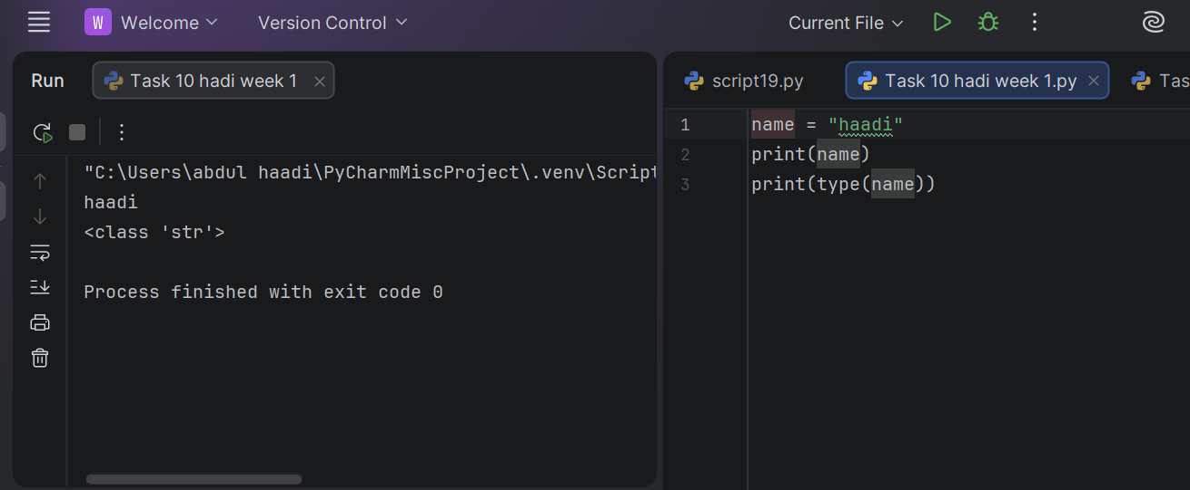

Task 2:
Use print( ) statement to display a star pattern in the shape shown below
Result:

Task 3:
Write a Python program to convert a temperature from celsius to Fahrenheit

Result:
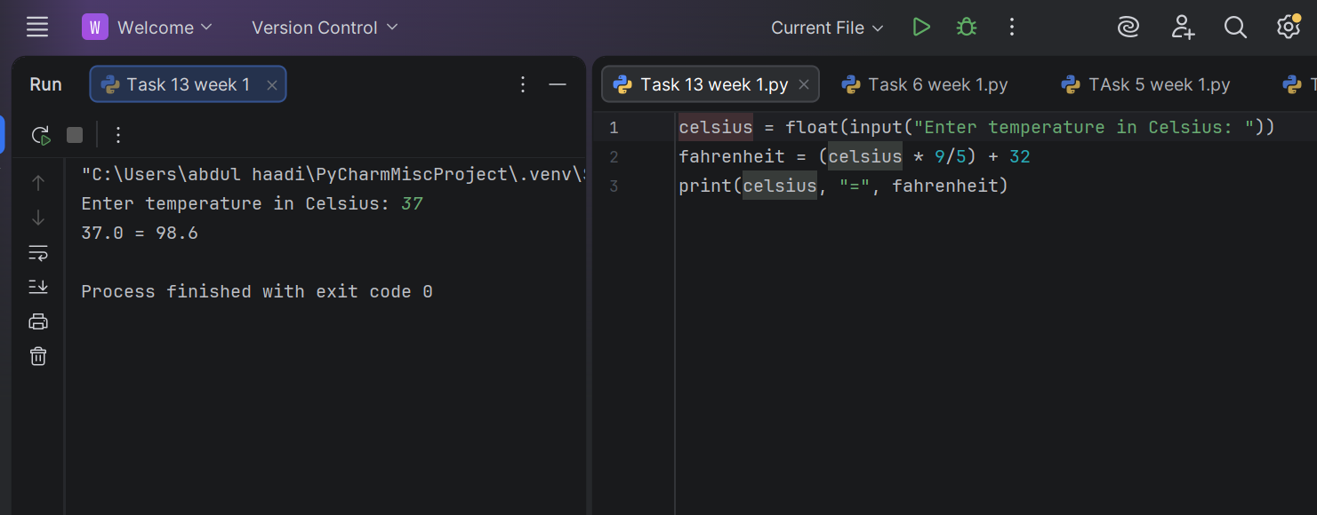

Task 4:

Write a python program that takes input from the user and prints the output

Result:

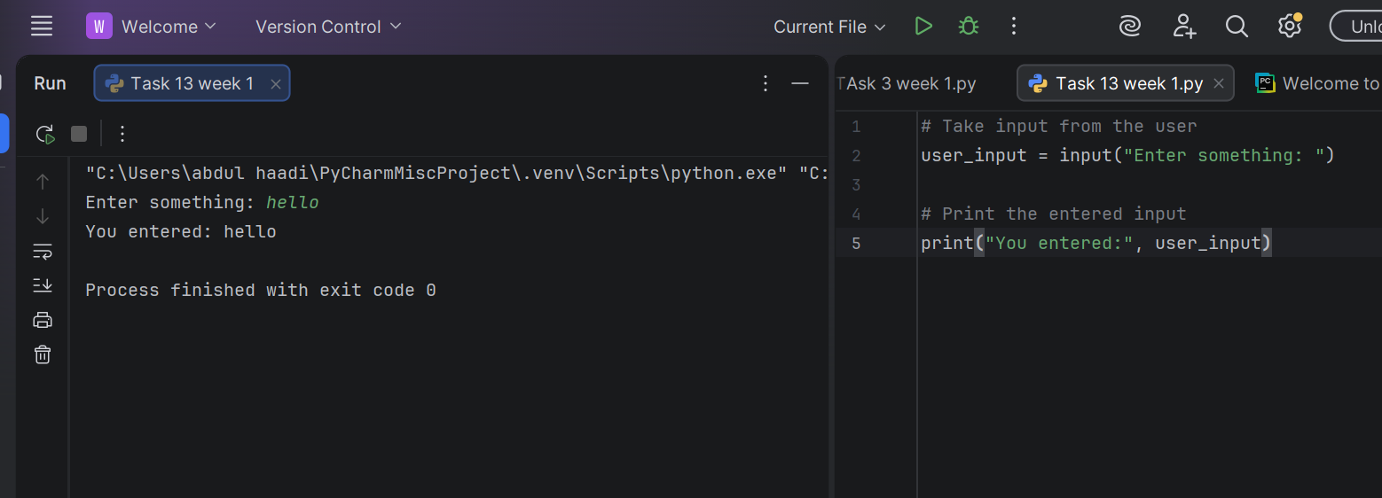

Task 5:

Write a python program that takes input and convert number of
bytes into mega bytes and gigabytes

Result:
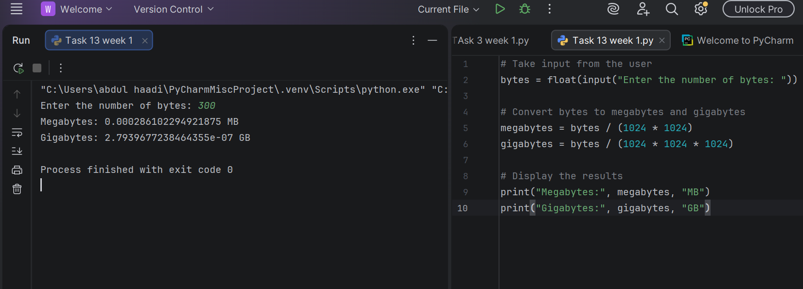

Task 6:

Write a Python program to calculate a student's aggregate percentage using ECAT 33%, Intermediate 50%, and Matric 17% weights and display it rounded to 2 decimal places.

Result:
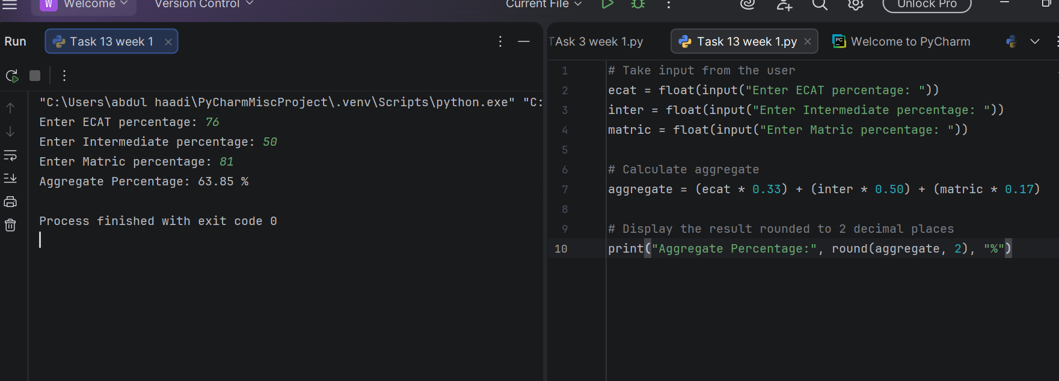

Task 7:

Write a Python program that prints the type of the variable

Result:
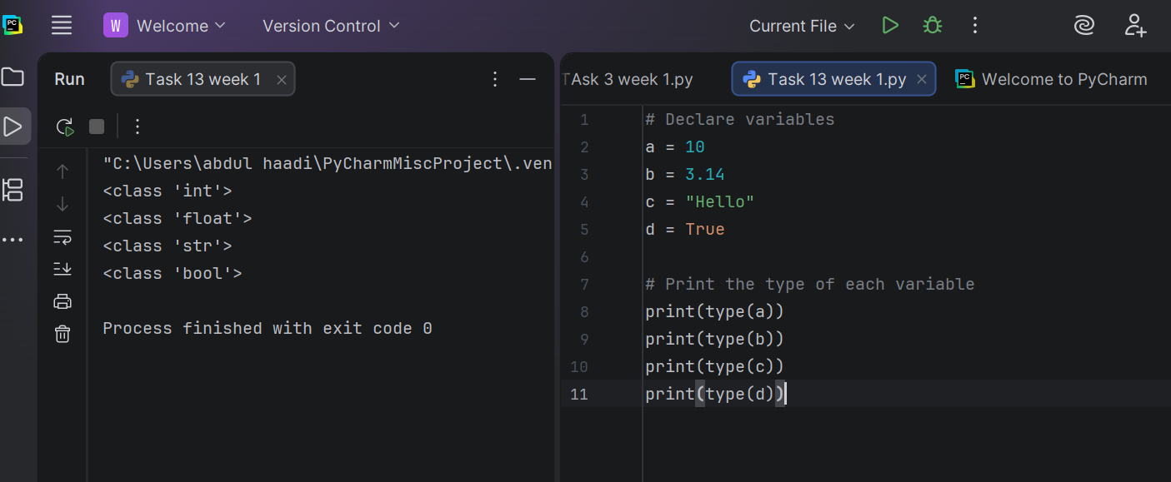

Task 8
Identify the data type of the variable age in the program.

Result

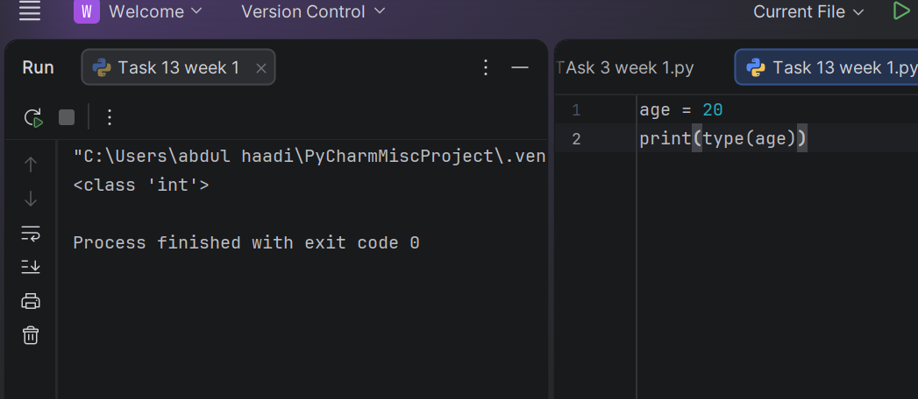

Task 9
Identify the data type in the program.

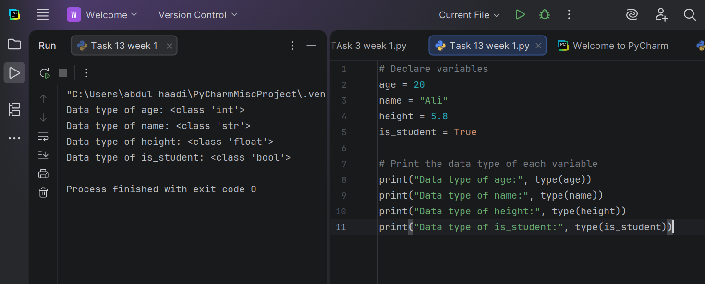

Task 11
Explain the use of int() and float() type casting functions with example in code.

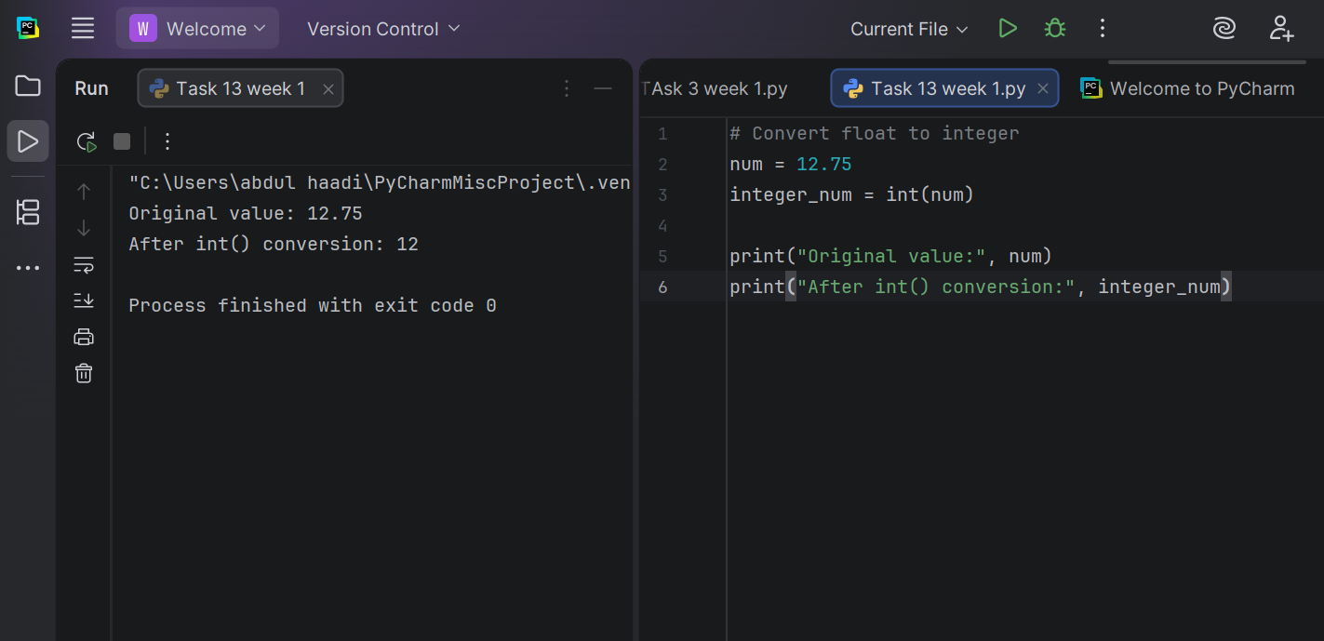

Task 12
What will be the output if int() was removed and we wrote a=1 and b=2 ?
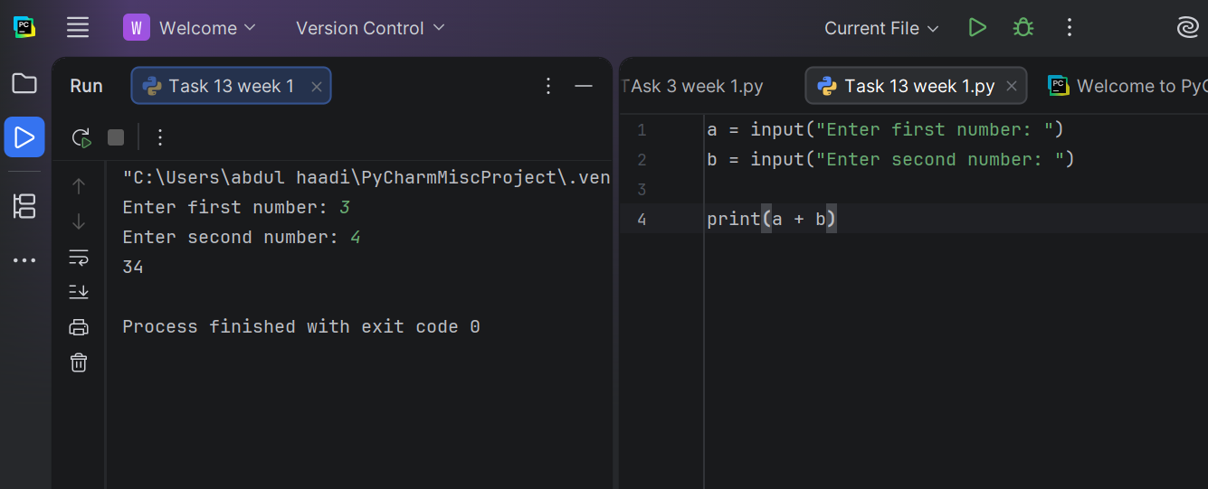

Task 13

Write a python program that takes input from user for obtained marks and total marks.

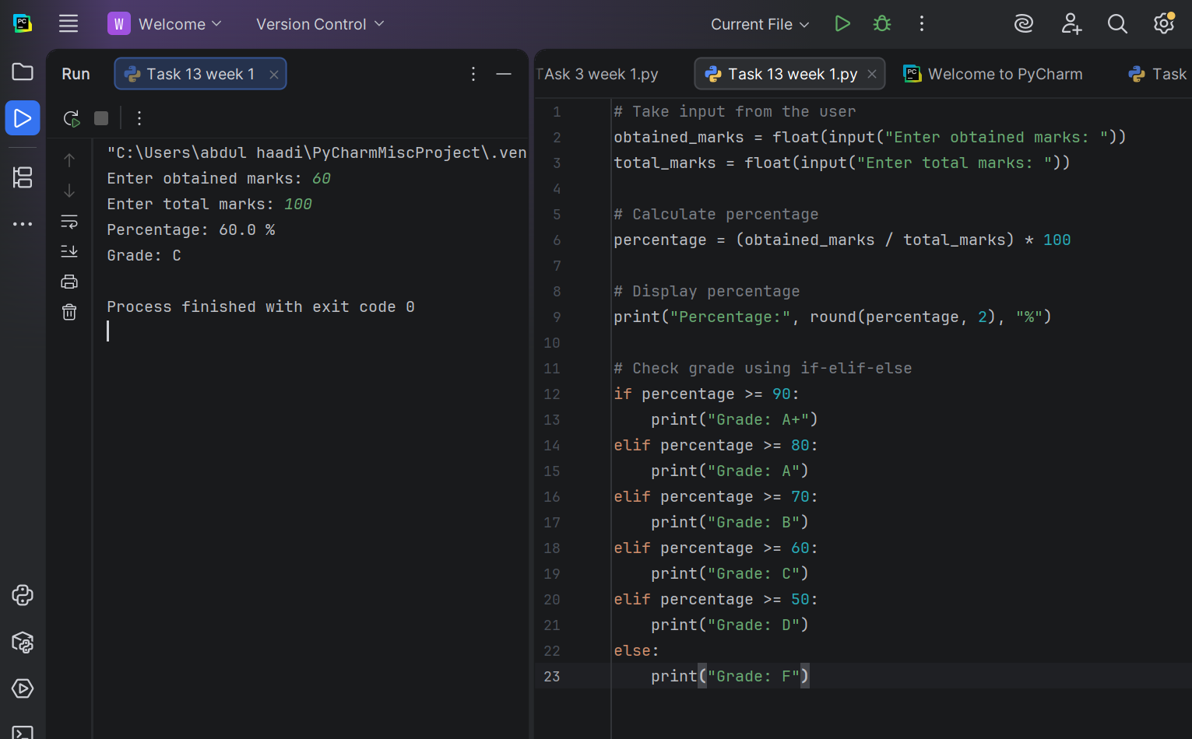

Task 14
Write a python program to find the roots of a quadratic equation.

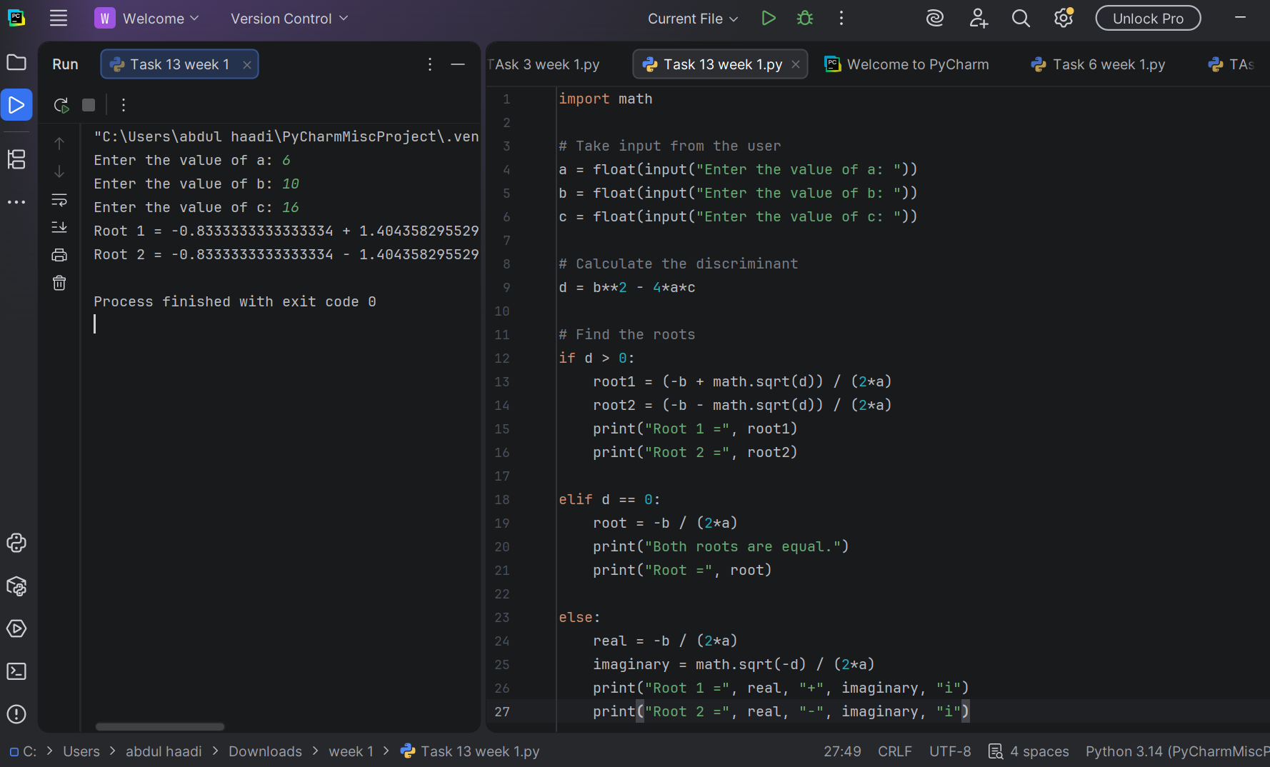

Task 15
Write a python program to check whether a given number is a Palindrome Number or not.

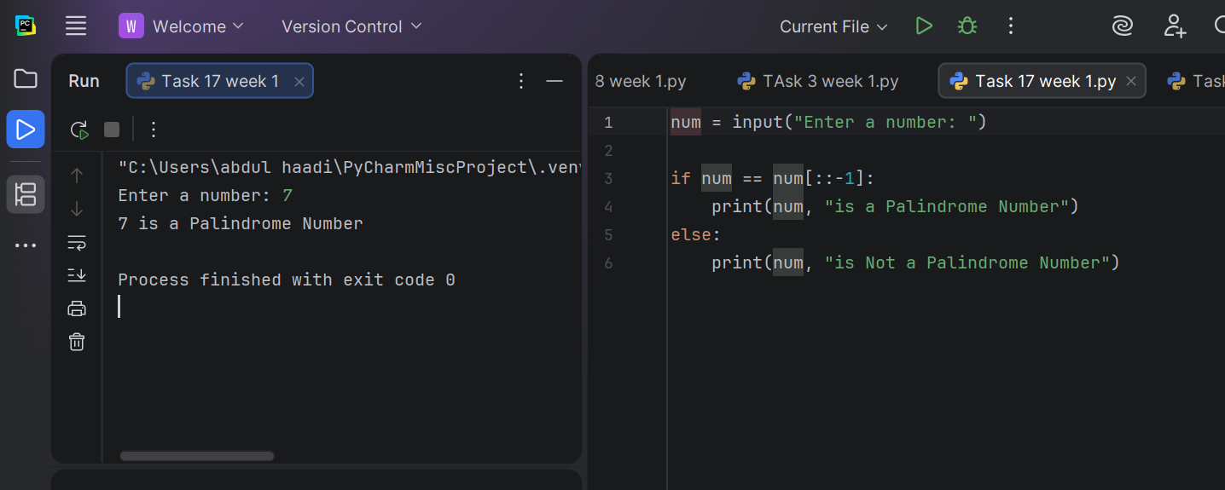
Task 16
Write a python program that works with two points in a 2D Cartesian Plane.

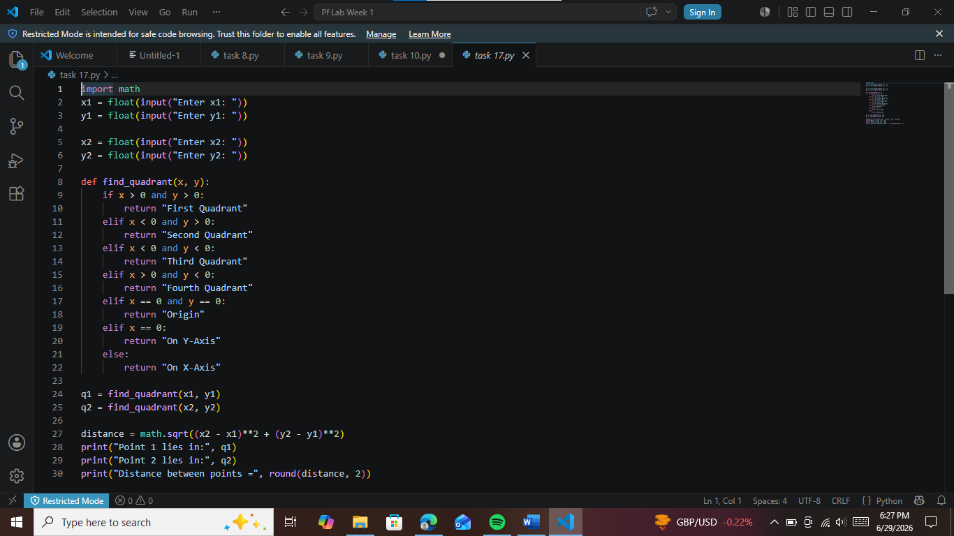

Conclusions:
Students learned basic Python concepts including input/output, data types, operators, and decision-making using conditional statements.

